Texas Online Metals Batch Upload Format
  - Version 2.0 Changes

The Metal Recycling Program offers an upload utility by which data can be exported from an external system and uploaded to the website. The old version 1.5 file format has been retired and replaced with a new version 2.0 file format.
If your company utilizes this upload function, you must update your system to start generating the new file format (known as “version 2.0”).
IMPORTANT: If you use 3rd party software for generating this file, you must notify them of this change.

Cutoff Date
The website temporarily supports uploading both old and new file formats. You must update your system to generate the new 2.0 file format BEFORE the cutoff date.
IMPORTANT: The Version 1.5 file format will no longer be accepted starting March 1st, 2022

What has Changed
A new format file has been defined for uploading transactions to the Texas Online Metals website. This new format has two changes:
- Support for reporting CCID when reporting a Catalytic Converter
(See #1 below)
- Removal of support for reporting MetalPartCount
(See #2 below)
Examples of these changes can be found below.
The interface for manually entering sales transactions has already been updated to support these changes.
Additional documentation about the file format can be found here:
https://texasonlinemetals.dps.texas.gov/Transaction/Upload/AboutUpload

Catalytic Converter ID (CCID)
The Catalytic Converter ID (CCID) must be included when reporting a Metal Form Type of REGULATEDMETALS-CATALYTIC_CONVERTER. The CCID must be valid for the CertificateID associated with the reported transaction. The CCID starts with a 3-character MRE Location ID(MLID) that is assigned to each Certificate ID.
The MLID’s assigned to your Certificate ID can be found here:
https://texasonlinemetals.dps.texas.gov/MRE/AppStatus/PrintCertificate

Examples of Format Changes:

Example 1: Showing new field for CCID value
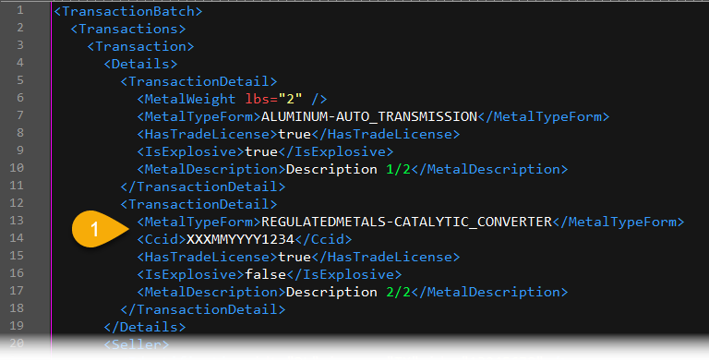

Example 2: Showing the removed MetalPartCount field
